SE3050 – User Experience Engineering

Lab Sheet 5

Sketches, Wire frames and Prototypes

Sketches, Wire frames and Prototypes

Codebusters

2021S2_REG_WD_03

|  |  |
| --- | --- |
| **IT NUMBER** | **Name** |
| IT19122656 | Kavishka K.A.L |
| IT19048642 | Rashmi Raveena .S |
| IT19023410 | Masakorala M.H |
| IT19158396 | Amarasinghe C.K. |

Instructions:

* Sketching: Sketching is a very efficient way of communicating design while allowing designers to try out a multitude of ideas and iterate them before settling on one.
* Wireframes: Wire framing is a practice, mostly used by UX designers. This process allows all stakeholders to agree on where the information will be placed before the developers build the interface out with code.
* Prototype (Low-fidelity or high-fidelity): Outline of the product. Generally, not interactive and are considered as static elements. Helps map out the shell of user interface and the underlying information architecture.
* User Feedback for your Prototype: Show your prototype (version 1.0) to users (use the same user selection) and get their feedback. You can improve your prototype create prototype (version 2.0) according to the user’s comments.

Contents

Prototype : 3

Interview Video link: 3

Member 01 Interfaces (IT19122656) 3

Member 2 Interfaces (IT19048642) 18

Member 3 Interfaces (IT19023410) 27

Member 4 Interfaces (IT19158396) 46

Interview Script 58

# Prototype :

Version 1: <https://www.figma.com/proto/2iCQlZSAIQFCEmsyqqclPw/Untitled?node-id=56%3A200&scaling=scale-down&page-id=50%3A664&starting-point-node-id=93%3A84&show-proto-sidebar=1>

version 2:<https://www.figma.com/proto/2iCQlZSAIQFCEmsyqqclPw/Untitled?node-id=142%3A975&scaling=scale-down&page-id=0%3A1&starting-point-node-id=93%3A201>

# Interview Video link:

<https://web.microsoftstream.com/video/741488f2-89c2-4442-84cc-861dd33a5e73>

# Member 01 Interfaces (IT19122656)

**Interface 1 – Login page**

* Sketches :

|  |
| --- |
| WhatsApp Image 2021-09-11 at 1C:\Users\lk\AppData\Local\Microsoft\Windows\INetCache\Content.Word\WhatsApp Image 2021-09-11 at 1.54.14 AM.JPEG |

* Wireframes :

|  |  |
| --- | --- |
| Prototype Version 1  C:\Users\lk\AppData\Local\Microsoft\Windows\INetCache\Content.Word\Login.png | Prototype Version 2login wireframe |

Prototype:

|  |  |
| --- | --- |
| * Prototype (Version 1.0):   C:\Users\lk\AppData\Local\Microsoft\Windows\INetCache\Content.Word\WhatsApp Image 2021-09-11 at 2.22.59 AM.JPEG | * Prototype (Version 2WhatsApp Image 2021-09-11 at 1. |

**Interface 2 – Registration page**

* Sketches :

|  |
| --- |
| WhatsApp Image 2021-09-11 at 1WhatsApp Image 2021-09-11 at 1 |

* Wireframes :

|  |  |
| --- | --- |
| Prototype (Version 1.0):  C:\Users\lk\AppData\Local\Microsoft\Windows\INetCache\Content.Word\register.png | Prototype (Version 2.0):Register wireframe |

* Prototype

|  |  |
| --- | --- |
| Prototype (Version 1.0):  WhatsApp Image 2021-09-11 at 2 | Prototype (Version 2.0):  C:\Users\lk\AppData\Local\Microsoft\Windows\INetCache\Content.Word\WhatsApp Image 2021-09-11 at 2.27.38 AM.JPEG |

**Interface 3 –Forgot Password page**

* Sketches :

|  |
| --- |
| WhatsApp Image 2021-09-11 at 1WhatsApp Image 2021-09-11 at 1 |

* Wireframes :

|  |  |
| --- | --- |
| Prototype (Version 1.0):  C:\Users\lk\AppData\Local\Microsoft\Windows\INetCache\Content.Word\forgot password.png | Prototype (Version 2.0):  C:\Users\lk\AppData\Local\Microsoft\Windows\INetCache\Content.Word\Forget password wireframe.png |

* Prototype:

|  |  |
| --- | --- |
| Prototype (Version 1.0):  WhatsApp Image 2021-09-11 at 2 | Prototype (Version 2.0):  C:\Users\lk\AppData\Local\Microsoft\Windows\INetCache\Content.Word\WhatsApp Image 2021-09-11 at 1.56.44 AM.JPEG |

**Interface 4 –Seller Profile**

* Sketches :

|  |
| --- |
| WhatsApp Image 2021-09-11 at 1 |

* Wireframes :

|  |  |
| --- | --- |
| Seller profilePrototype (Version 1.0) | Prototype (Version 2.0):  Seller profile wireframe |

* Prototype:

|  |  |
| --- | --- |
| Prototype (Version 1.0):  C:\Users\lk\AppData\Local\Microsoft\Windows\INetCache\Content.Word\WhatsApp Image 2021-09-11 at 2.32.30 AM.JPEG | Prototype (Version 2.0):  C:\Users\lk\AppData\Local\Microsoft\Windows\INetCache\Content.Word\WhatsApp Image 2021-09-11 at 1.56.44 AM (1).jpeg |

**Interface 5 –Buyer Profile**

* Sketches :

|  |
| --- |
| WhatsApp Image 2021-09-11 at 1 |

* Wireframes :

|  |  |
| --- | --- |
| Prototype (Version 1.0):  **C:\Users\lk\AppData\Local\Microsoft\Windows\INetCache\Content.Word\buyer profile.png** | Prototype (Version 2.0):  C:\Users\lk\AppData\Local\Microsoft\Windows\INetCache\Content.Word\buyer profile wireframe.png |

* Prototype

|  |  |
| --- | --- |
| Prototype (Version 1.0):  **C:\Users\lk\AppData\Local\Microsoft\Windows\INetCache\Content.Word\WhatsApp Image 2021-09-11 at 3.02.13 AM.JPEG** | Prototype (Version 2.0):  **C:\Users\lk\AppData\Local\Microsoft\Windows\INetCache\Content.Word\WhatsApp Image 2021-09-11 at 1.56.45 AM.JPEG** |

**Interface 6 –Edit profile page**

* Sketches :

|  |
| --- |
| WhatsApp Image 2021-09-11 at 1 |

* Wireframes :

|  |  |
| --- | --- |
| Prototype (Version 1.0):  C:\Users\lk\AppData\Local\Microsoft\Windows\INetCache\Content.Word\edit profile.png | Prototype (Version 2.0):  edit profile wireframe |

* Prototype

|  |  |
| --- | --- |
| WhatsApp Image 2021-09-11 at 3Prototype (Version 1.0): | WhatsApp Image 2021-09-11 at 1Prototype (Version 2.0): |

**Interface 7 –Change password page**

* Sketches :

|  |
| --- |
| C:\Users\lk\AppData\Local\Microsoft\Windows\INetCache\Content.Word\WhatsApp Image 2021-09-11 at 1.55.45 AM.JPEGWhatsApp Image 2021-09-11 at 1 |

* Wireframes :

|  |  |
| --- | --- |
| Prototype (Version 1.0):  change password | Prototype (Version 2.0):  C:\Users\lk\AppData\Local\Microsoft\Windows\INetCache\Content.Word\change password wireframe.png |

* Prototype

|  |  |
| --- | --- |
| C:\Users\lk\AppData\Local\Microsoft\Windows\INetCache\Content.Word\WhatsApp Image 2021-09-11 at 3.18.45 AM.JPEGPrototype (Version 1.0): | Prototype (Version 2.0):  WhatsApp Image 2021-09-11 at 1 |

# Member 2 Interfaces (IT19048642)

**Interface 1 – Feedback**

* Sketches:

|  |  |
| --- | --- |
| E:\SLIIT\3rd year\2nd sem\UEE\project\Sketch\IMG20210911192604.jpg | E:\SLIIT\3rd year\2nd sem\UEE\project\Sketch\IMG20210911192450.jpg |
| E:\SLIIT\3rd year\2nd sem\UEE\project\Sketch\IMG20210911192615.jpg |

* Wire frame:

|  |
| --- |
|  |

Prototypes:

|  |  |
| --- | --- |
| Version 01 | Version 02 |
|  |  |

**Interface 2 – About Us**

* Sketches:

|  |  |
| --- | --- |
| E:\SLIIT\3rd year\2nd sem\UEE\project\Sketch\IMG20210911190345.jpg | E:\SLIIT\3rd year\2nd sem\UEE\project\Sketch\IMG20210911190412.jpg |

* Wire frame:

|  |
| --- |
|  |

* Prototypes:

|  |  |
| --- | --- |
| Version 01 | Version 02 |
|  |  |

**Interface 2 – Contact Us**

* Sketches:

|  |  |
| --- | --- |
| E:\SLIIT\3rd year\2nd sem\UEE\project\Sketch\IMG20210911190457.jpg | E:\SLIIT\3rd year\2nd sem\UEE\project\Sketch\IMG20210911190450.jpg |
| E:\SLIIT\3rd year\2nd sem\UEE\project\Sketch\IMG20210911192215.jpg |

Wire frame:

|  |
| --- |
|  |

* Prototypes:

|  |  |
| --- | --- |
| Version 01 | Version 02 |
|  |  |

# Member 3 Interfaces (IT19023410)

**Interface 1 – Starting page**

Sketches:

|  |
| --- |
|  |

Wire frames:

|  |
| --- |
|  |

Prototype:

|  |  |
| --- | --- |
| Version 1 | Version 2 |
|  |  |

**Interface 2 – Home Page**

Sketches:

|  |
| --- |
|  |

Wire frames:

|  |
| --- |
|  |

Prototype:

|  |  |
| --- | --- |
| Version 1 | Version 2 |
|  |  |

**Interface 3 – Add Payment Details Page**

Sketches:

|  |
| --- |
|  |

Wire frames:

|  |
| --- |
|  |

Prototype:

|  |  |
| --- | --- |
| Version 1 | Version 2 |
|  |  |

**Interface 4 – Payment Page**

Sketches:

|  |
| --- |
|  |

Wire frames:

|  |
| --- |
|  |

Prototype:

|  |  |
| --- | --- |
| Version 1 | Version 2 |
|  |  |

**Interface 5 – Edit Payment Details Page**

Sketches:

|  |
| --- |
|  |

Wire frames:

|  |
| --- |
|  |

Prototype:

|  |  |
| --- | --- |
| Version 1 | Version 2 |
|  |  |

**Interface 6 – Ad promote packages page**

Sketches:

|  |
| --- |
|  |

Wire frames:

|  |
| --- |
|  |

Prototype:

|  |  |
| --- | --- |
| Version 1 | Version 2 |
|  |  |
|  |  |

**Interface 7 – Ad publishing packages page**

Sketches:

|  |
| --- |
|  |

Wire frames:

|  |
| --- |
|  |

Prototype:

|  |  |
| --- | --- |
| Version 1 | Version 2 |
|  |  |
|  |  |

# Member 4 Interfaces (IT19158396)

**Interface 1 – Post an Ad Form Interface**

Sketches:

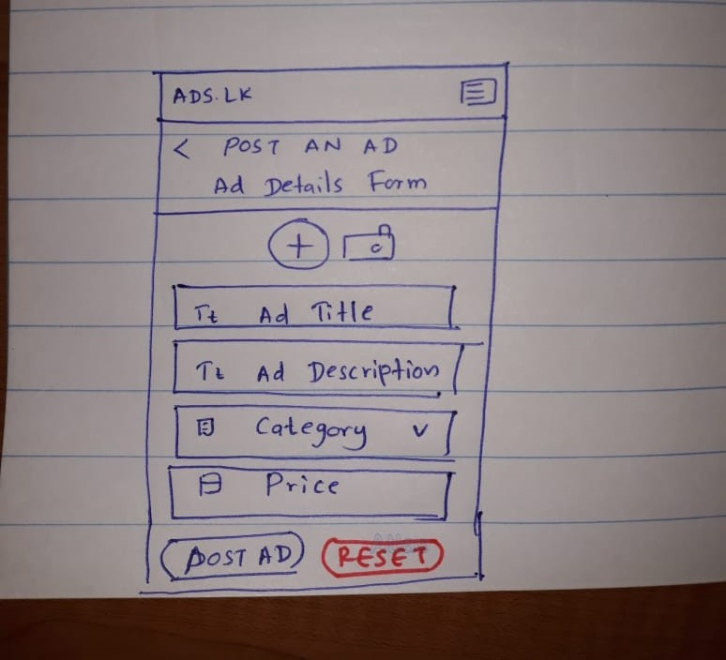

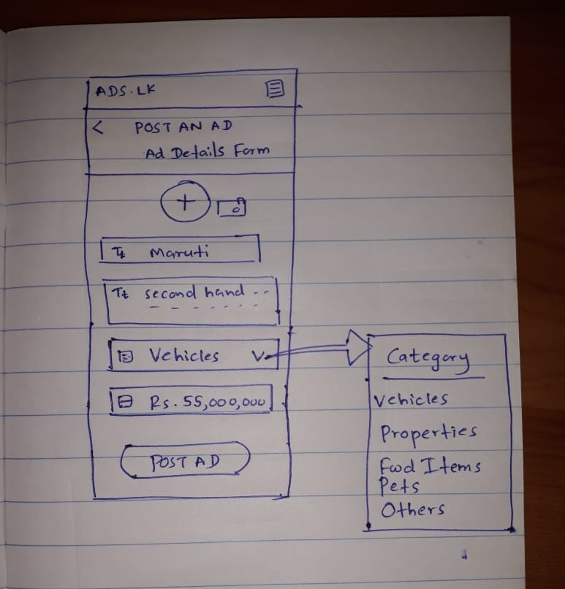

Wire frames:

For Prototype Version 2

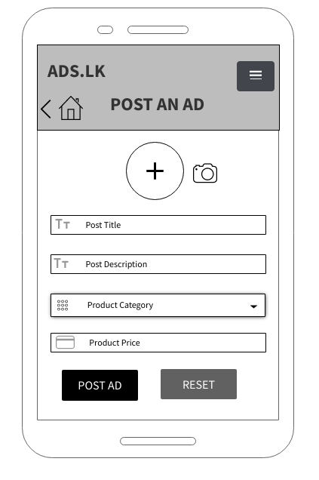

For Prototype Version 1

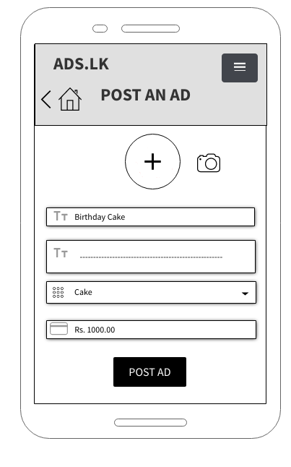

Prototype:

Prototype Version 2

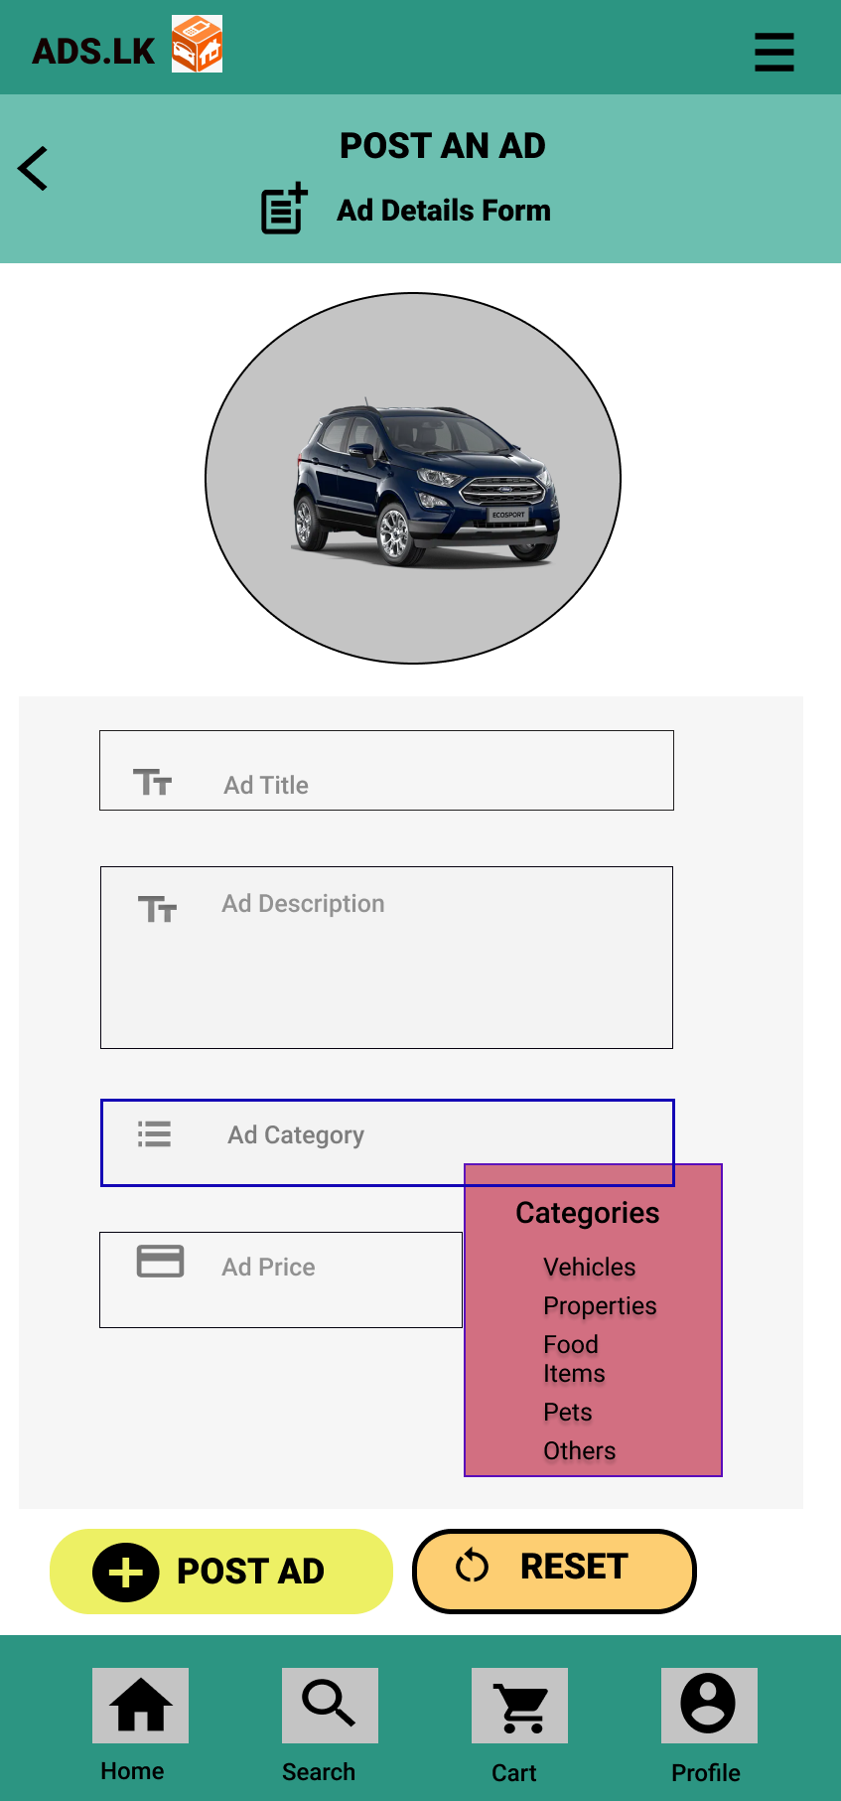

Prototype Version 1

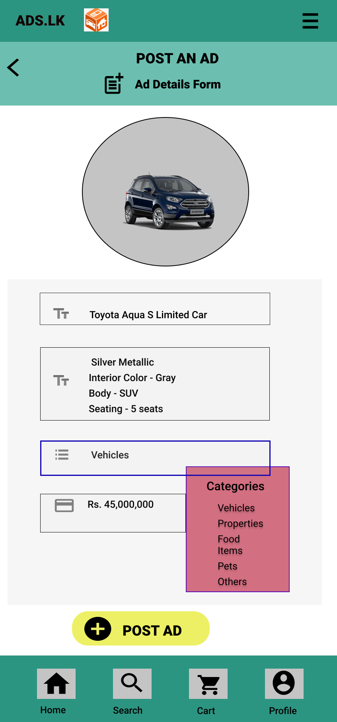

**Interface 2 – Seller Details and Other Ads Interface**

Sketches:

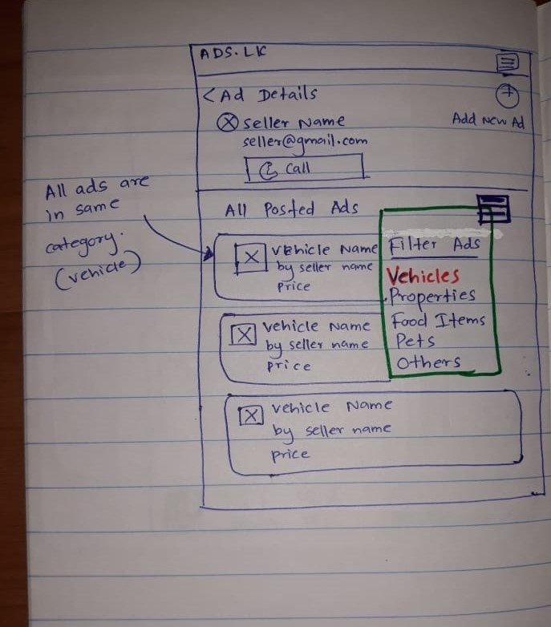

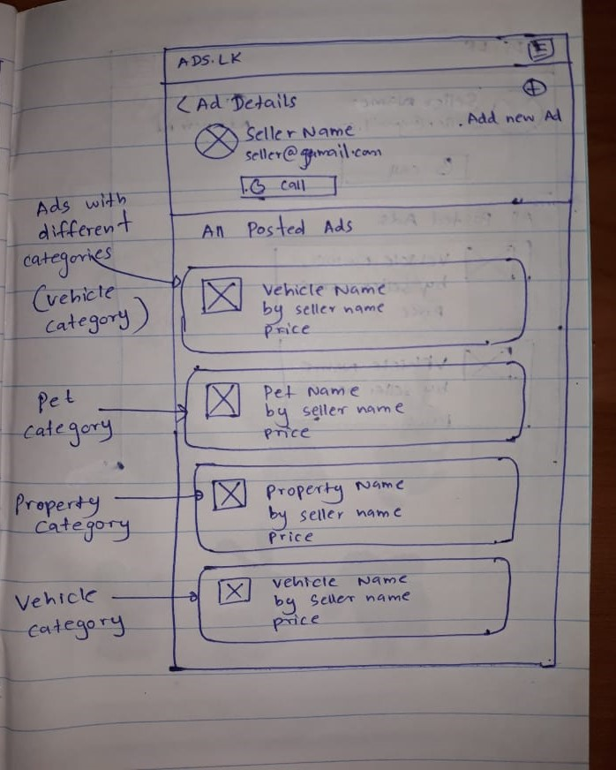

Wire frames:

For Prototype 1

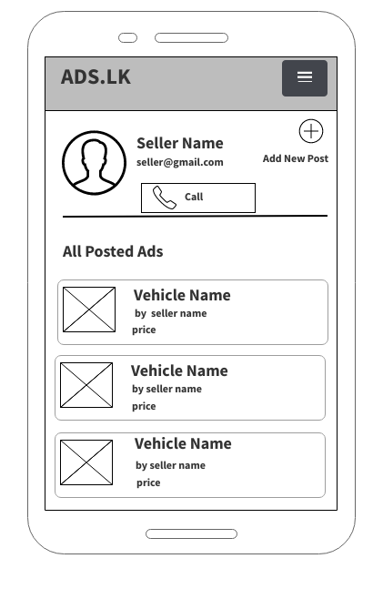

For Prototype 2

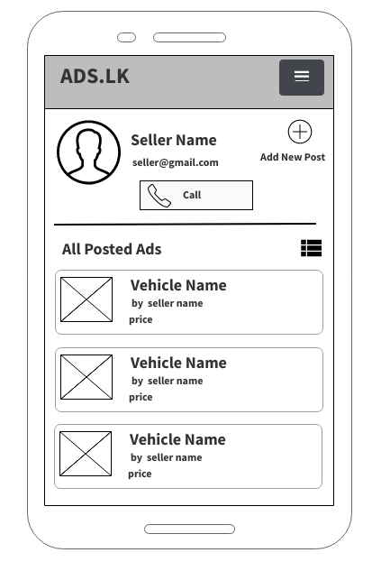

Prototypes:

Prototype Version 1

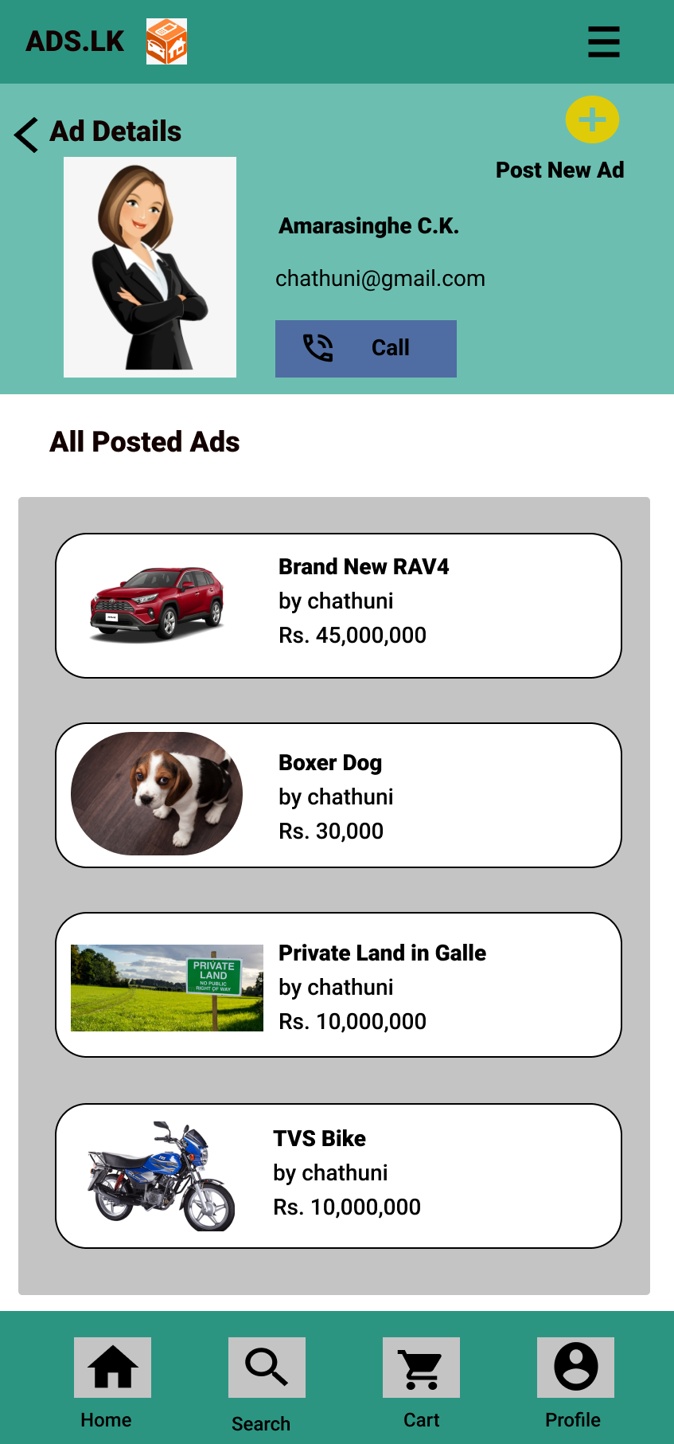

Prototype Version 2

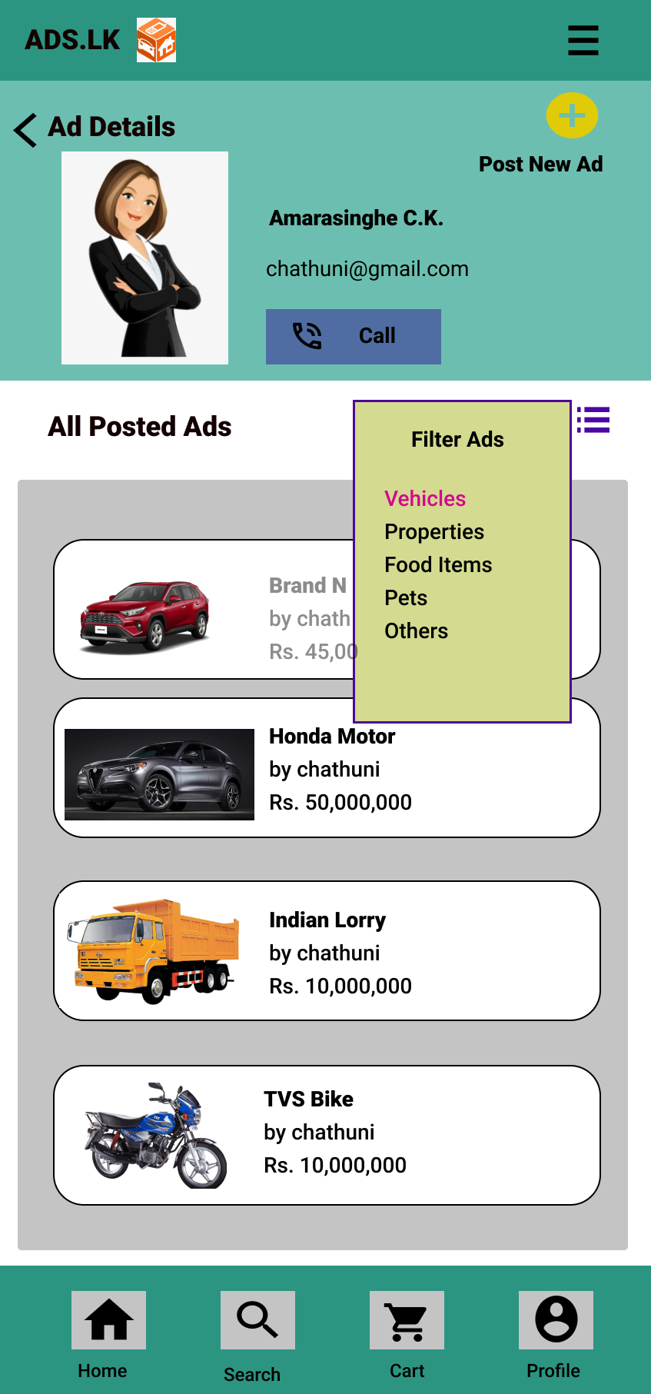

**Interface 3 – Ad Details Interface (View single ad)**

Sketches:

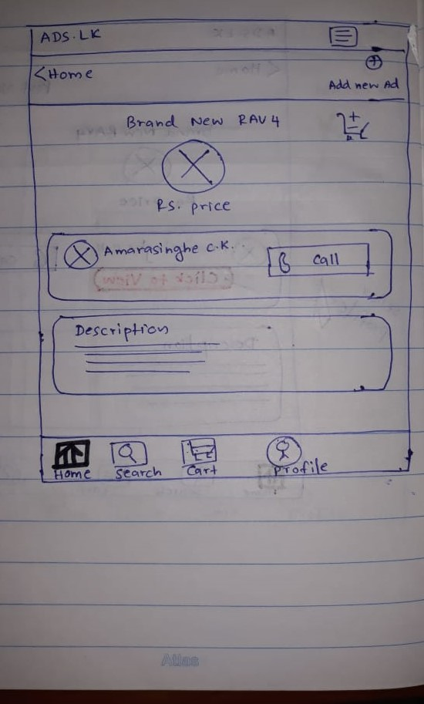

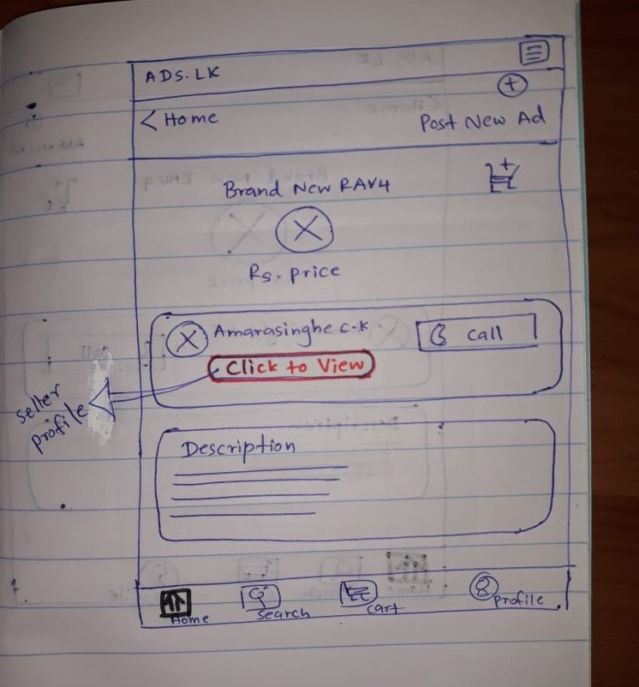

Wire Frames:

For Prototype 2

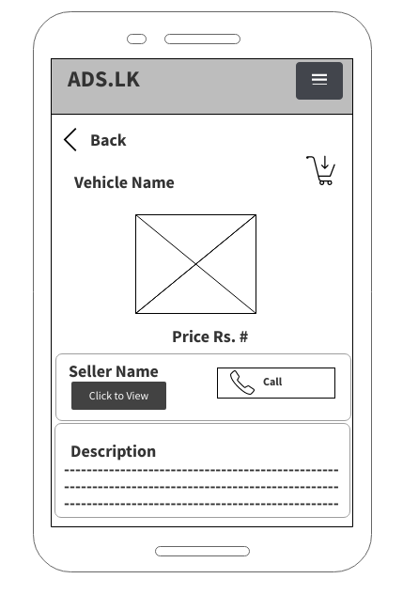

For Prototype 1

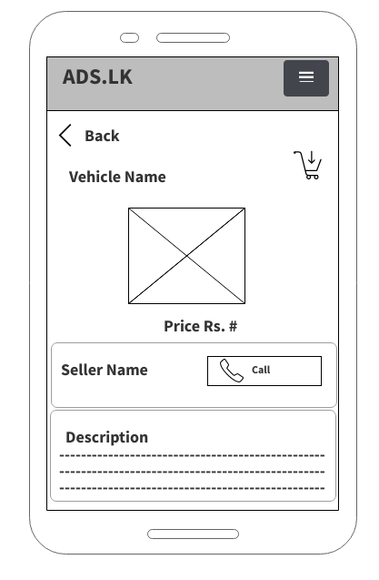

Prototypes:

Prototype Version 2

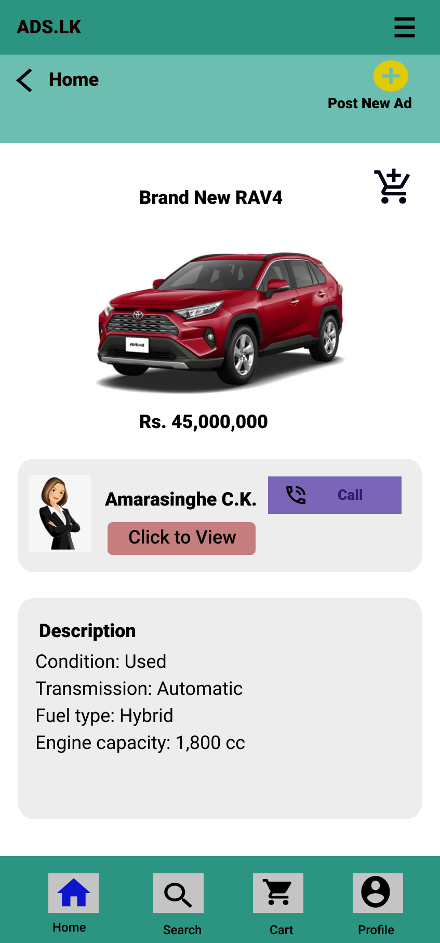

Prototype Version 1

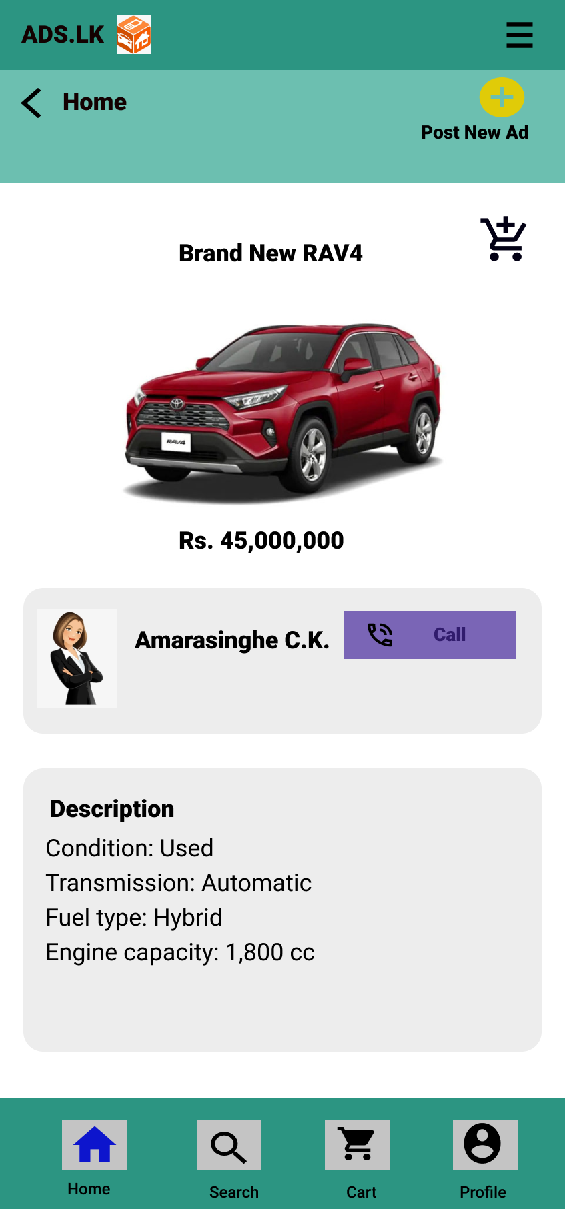

**Interface 4 – Shopping Cart (Show items to cart)**

Sketches:

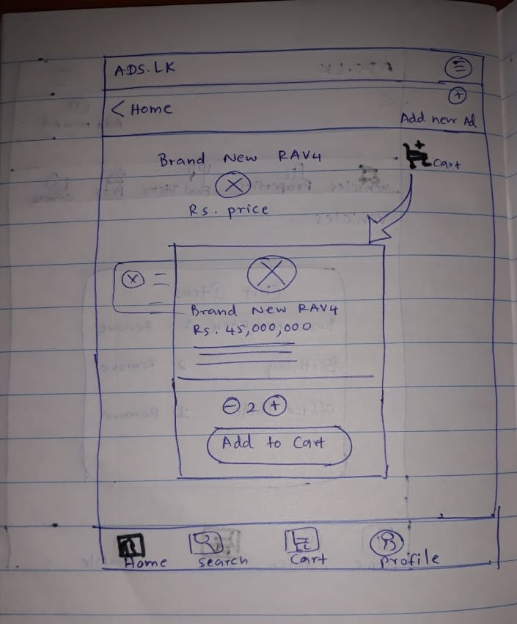

Wire Frames:

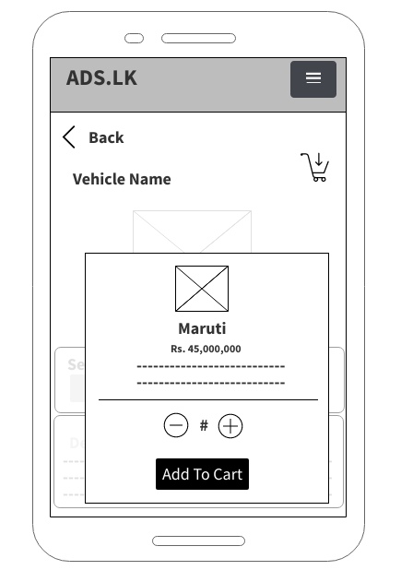

Prototype:

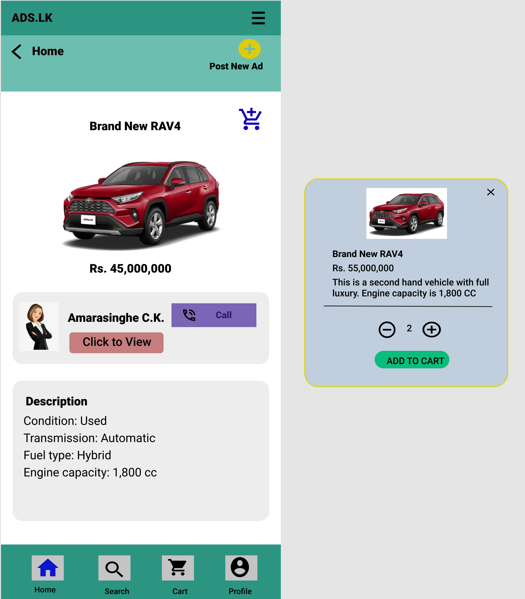

**Interface 5 – Shopping Cart (Show cart items)**

Sketches:

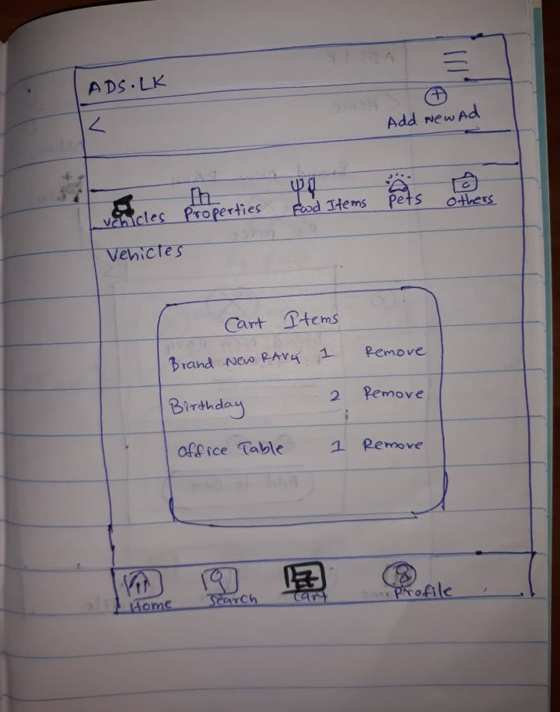

Wire Frames:

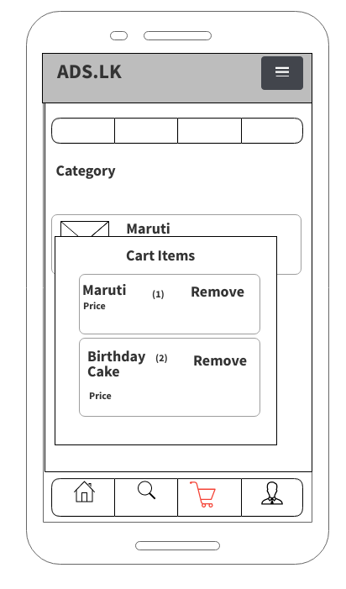

Prototypes:

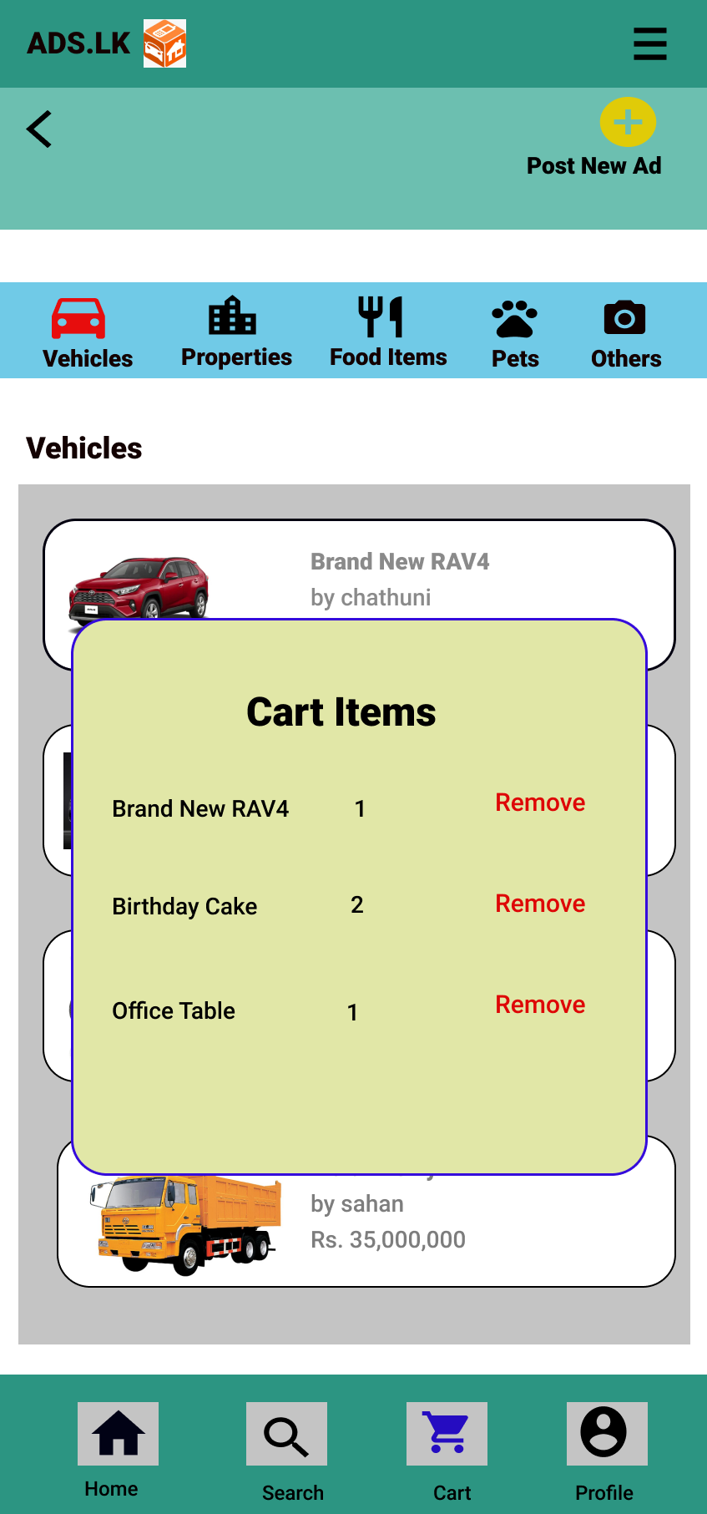

# Interview Script

**Photographer Interview**

I am (Name) and we warmly welcome you for our 2nd interview about Ads.lk mobile application. As you know we held our previous interview to find user experience and user friendliness of this application. We analyzed your thoughts and come up with a new user interface designs and new functionalities. Therefore, we are here to present our newly created user interfaces and willing to gather your valuable feedbacks. We would like to inform you your ideas are highly precious to us. We are getting your ideas to improve our new designs and finalize user interfaces before switch into the development process.

We have already started to record this interview under your permission. And again I would like to inform you we would not share this recording with anyone else other than our team members and marking panel. While we are conducting the interview our team members will note down your feedbacks and analyze them. Now I will hand over the rest of the interview to (Name). Thank you

1. As a buyer you have shared your idea about the registration process during our previous interview. What do you think about the attractiveness of this new login and registration interface compared to old one?

This is colorful and I like the arraignment of this interface. So, I think this is more attractive than the previous one.

1. This is the user profile interface. What do you think about features arrangement like profile picture, user details and buttons?

I like the arrangement of profile pictures and user details. But Button arrangement looks like little bit complex.

1. This is our new re-set password interface. What do you think about this interface?

Overall I like this but it would be better if this ask for user name too. It may improve the security of this process.

1. As your opinions in previous interview you have shared that product searching is too complex and time consuming. Therefore, we consider it and re-design this interface. So I would like to know your idea about this new interface.

Great, As I can see you have added searching feature. And it will be very easy to find required product with this product categorization.

1. Since there was no any cart option in previous application we have added that option to our new version. We think that it will fulfill your need of cart option.

Yes, after adding products into cart it will be very useful when I’m comparing different products in same category. Because of this, I will be able to buy specific quality product. And also I like this appearance of it.

1. You can see all the details of specific product through this interface. What do you think about the details arrangement and displayed information in this interface with compared to previous one?

Details arrangement is fine. I think this shows enough information about the product but It will be better to have a way for get more details about the product seller too.

1. We have designed a contact us interface for users. Do you think this interface needs any modification?

I prefer this facility because there will be some situations that we want to contact you. For modifications…. I think adding date is not that much important.

1. Ok this is the end of our interview. Finally, we would like to ask, overall idea about our new designs.

I can see that you have improved this application very well. I would like to appreciate you for considering my ideas that I gave you in previous interview.

Thank you for participate to our interview and spending your valuable time with us for improve our application.

**Business Women Interview**

I am (Name) and we warmly welcome you for our 2nd interview about Ads.lk mobile application. As you know we held our previous interview to find user experience and user friendliness of this application. We analyzed your thoughts and come up with a new user interface designs and new functionalities. Therefore, we are here to present our newly created user interfaces and willing to gather your valuable feedbacks. We would like to inform you your ideas are highly precious to us. We are getting your ideas to improve our new designs and finalize user interfaces before switch into the development process.

We have already started to record this interview under your permission. And again I would like to inform you we would not share this recording with anyone else other than our team members and marking panel. While we are conducting the interview our team members will note down your feedbacks and analyze them. Now I will hand over the rest of the interview to (Name). Thank you

1. As a seller you have shared your idea about the registration process during our previous interview. In there you have mentioned there was an issue regarding password confirmation. In our newly created registration interfaces we consider about those issues and re-designed it. So, do you satisfy with our new design?

Yeah…. I saw you have added confirm password field to that and there were new features also. That’s good but it would be better if you can change the way of account type selection in to an easy way. Other than that I am satisfying with the rest of the things.

1. As a regular customer, what is your opinion about the new design of login interface?

That’s an eye catching interface. I like the way of item arranged in here.

1. If I can remember correctly, you said form of post an advertisement was very complex and time consuming. So what do you think about this new post ad form and procedure?

In here I can easily get an idea about what I have to fill and I can post my ad within a short time period. But… If I want to clear all the filled fields at once, this doesn’t have such a feature right?

1. Thank you for your opinion and we will note it down and consider it the next version. Then we will move on to next interface. This is ad publishing packages page. Since there was not a page like this, I will quickly explain the page procedure to you. Using this page, you can buy packages to post advertisements. You need to select the preferred package and in next line it will display the amount automatically with your selection. Then add the date after that you can simply buy a package. According to your point of view, are there any modifications you would prefer?

I am happy with that feature, but I like to suggest to add a chart to display packages and

their prices in a separate view. It will become easy to compare packages and select.

1. We are happy to say, we have “added promote ad” feature that you wished to have in this application too. There also have packages to buy and same as the previous process. We think it will be useful to you.

Thank you for considering my idea. And if the process same as previous one, better to display packages details in a table.

1. Do you ever edited posted ads in this app? How was that facility?

Yes, I have tried it but it was difficult to get a specific ad quickly, because it displays all ads. So better to have a category search in there.

1. We re-designed the edit profile form by adding new features. During the previous interview you said that the edit profile form is much complex to handle. I hope now it reduces the complexity, Can I know what is your opinion about that?

Yes that’s good, now it is easy to handle and I am satisfied with that facility.

1. Ok. We will consider your valuable ideas when design the next version of these interfaces. We are going to gather your idea for our last interface that is contact us interface. What do you think about this new interface?

I can see there are sufficient information that would help to get an idea about this application. But I can’t understand about the content quickly. So.. I think It’s better to display the same content with topics or something.

1. Eventually we have reached to the end of our interview. We would like to ask, overall what do you feel about our new designs.

Actually I’m happy with these new interfaces. I would like to appreciate you for considering my ideas that I gave you in previous interview.

Thank you for spending your valuable time with us for improve our application.

|  |  |
| --- | --- |
| Registration Number | Name |
| IT19122656 | Creating figma prototypes for interfaces  Connect all prototypes  Help to create the document |
| IT19048642 | Creating figma prototypes for interfaces  Help to create the document  Creating scripts |
| IT19023410 | Creating figma prototypes for interfaces  Help to create the document  Creating scripts |
| IT19158396 | Creating figma prototypes for interfaces  Help to create the document  Creating scripts |